Exercise 6: Database Foundations
Step 1: Deploy MongoDB Locally via Docker
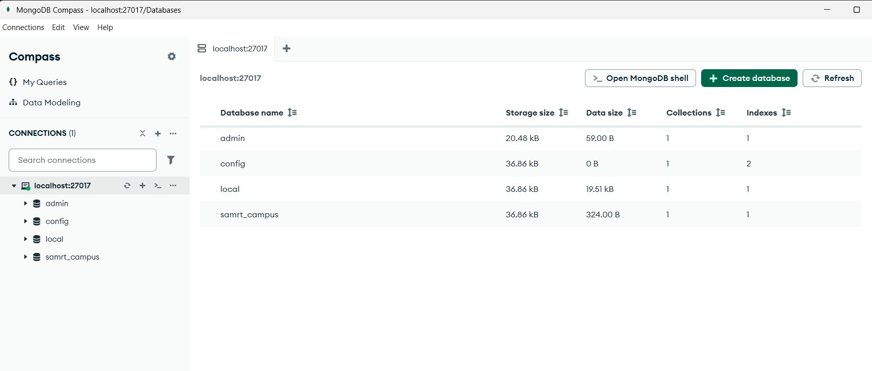

Step 2: Install MongoDB Nodes in Node-RED
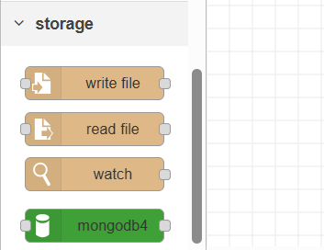

Step 3: Configure the Database Connection
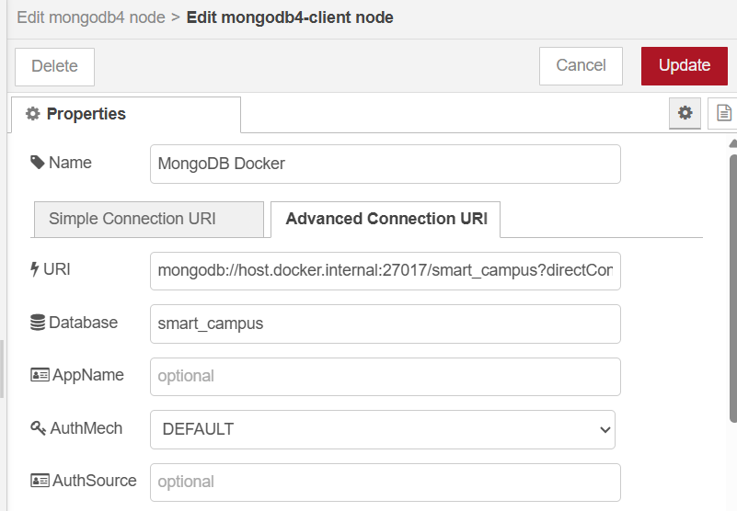

Step 4: Upgrading REST APIs to execute CRUD Operations

Part A: CREATE (HTTP POST)
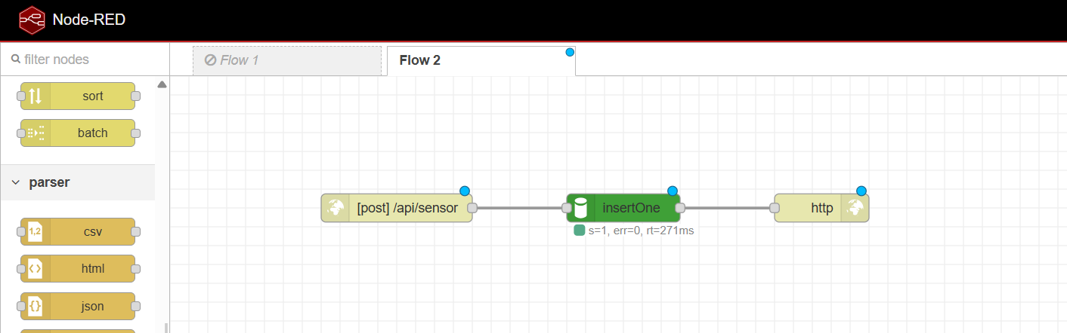

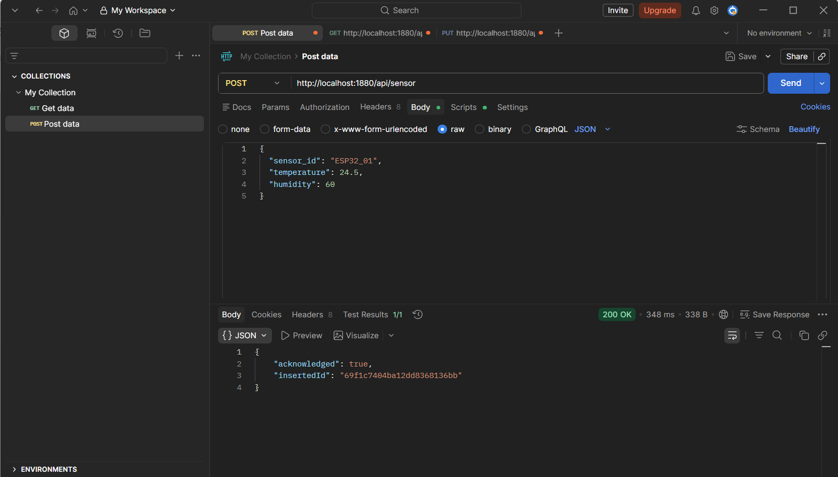

Part B: READ (HTTP GET)
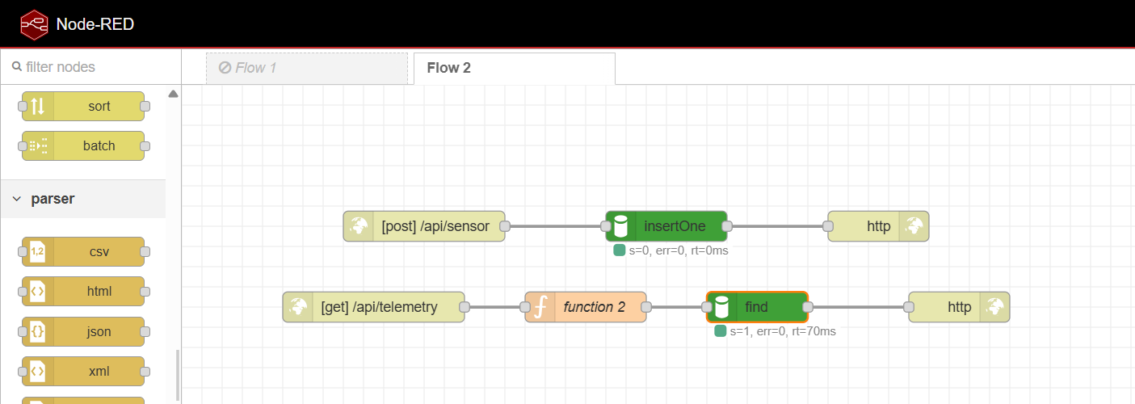
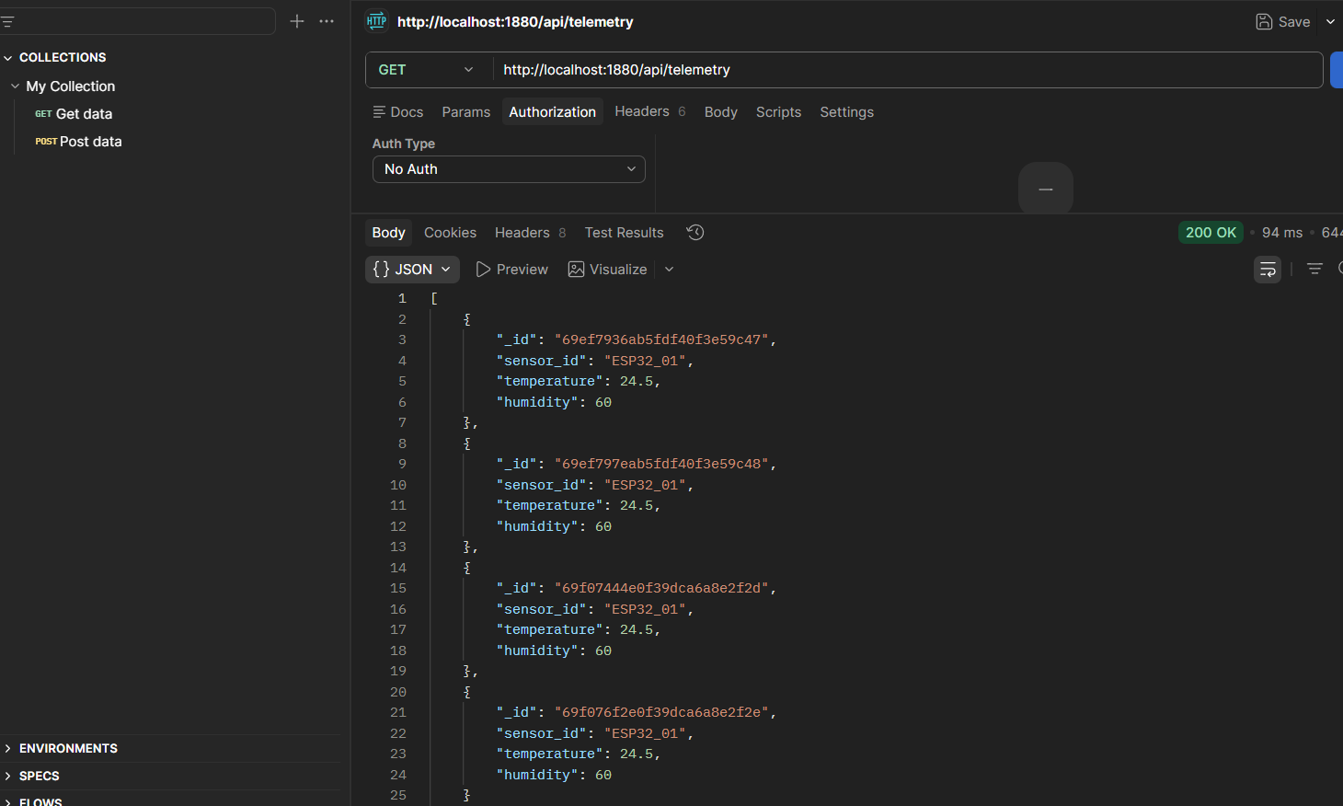

Part C: UPDATE & DELETE (Advanced Logic)
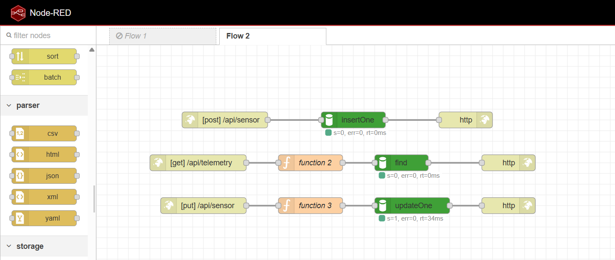
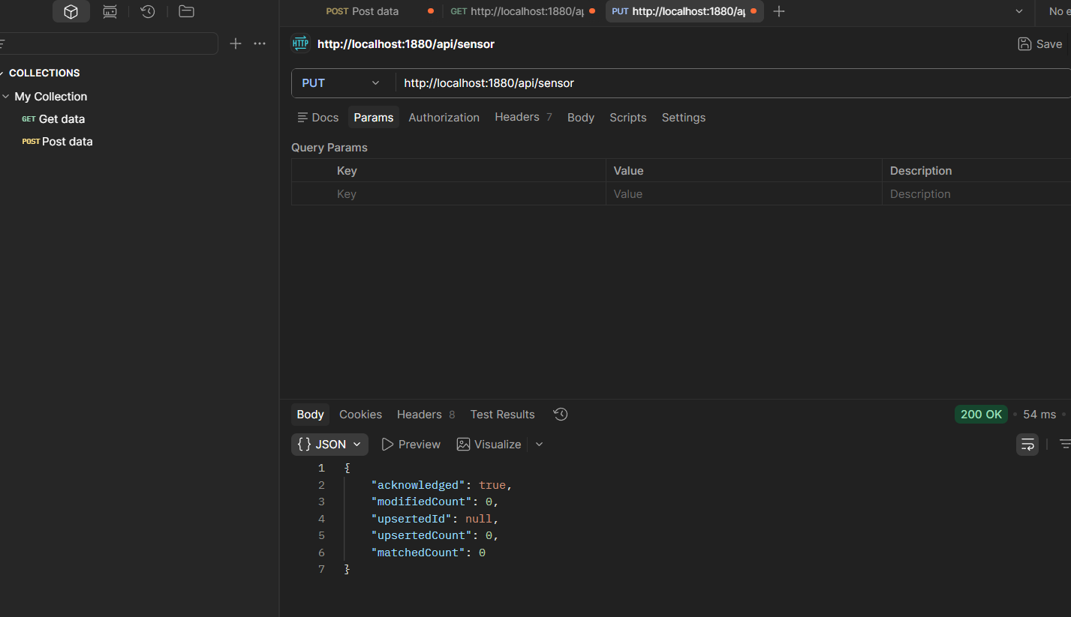

Question 1: Dynamic Schema Generation
MongoDB is schema-less, meaning documents in a collection do not need to follow one fixed table structure before data is inserted. You can store one sensor record with temperature and humidity, and another with extra fields like pressure or battery level, without altering a table definition first. This is very useful in early IoT prototyping because sensor formats often change as devices are tested, replaced, or upgraded. It lets you move fast without constantly redesigning the database schema.

Question 2: Middleware Abstraction
This architecture is safer because Node-RED acts as a controlled middle layer between clients and the database. The sensors or Postman only need to call HTTP endpoints, while Node-RED can validate data, transform payloads, enforce rules, and decide what database operation is allowed. Exposing MongoDB’s port 27017 directly to the public internet is dangerous because anyone could attempt unauthorized reads, writes, deletions, brute-force attacks, or exploit weak database settings. Keeping the database private and placing Node-RED in front of it reduces attack surface and gives you a single point for access control and logging.

